Cuomo Administration Moves to Ban Fracking

Environment, Health Concerns Cited in Barring Drilling in Marcellus Shale
By Erica Orden
Dec. 17, 2014
ALBANY, N.Y.—New York Gov. Andrew Cuomo’s administration said Wednesday it would prohibit hydraulic fracturing statewide, citing health concerns and calling the economic benefits to drilling there limited.
“I cannot support high-volume hydraulic fracturing in the great state of New York,” acting health commissioner Howard Zucker said, adding that he wouldn’t allow his own children to live near a fracking site. He said the “cumulative concerns” about fracking “give me reason to pause.”
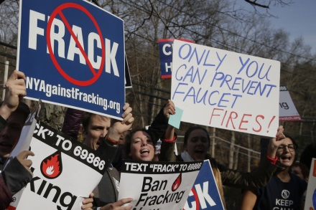
The New York State Department of Environmental Conservation will issue a legally-binding recommendation prohibiting fracking as a result of Mr. Zucker’s recommendation.
Supporters for New York Gov. Andrew Cuomo and anti-fracking demonstrators shout slogans outside a polling site in November. The governor’s administration said Wednesday it would prohibit hydraulic fracturing in the Marcellus Shale. Associated Press
Hydraulic fracturing in states such as North Dakota, Pennsylvania and Texas has fueled a natural gas and oil boom, helping to drive the world’s crude oil prices dramatically down. It is credited with helping some local economies, but also sparked a debate about whether it harms the environment.
High-volume fracking combines high-pressure water and materials such as sand and chemicals to break open cracks in rock deep underground. A method called horizontal drilling along with fracking is used to extract natural gas.
New York’s environment commissioner, Joe Martens, said his agency’s concerns about the impact of fracking would so limit the area that could be drilled in the 12 million-acre Marcellus Shale that the economic benefits of drilling there would be limited.
“The economic benefits [of fracking] are clearly far lower than originally forecast,” Mr. Martens said.
Mr. Cuomo himself said the decision was made by his commissioners, not him. “I don’t think I even have a role here,” he said at a news conference.
Wednesday’s determination marks a turning point on an issue that has bedeviled Mr. Cuomo since he took office in January 2011.
The state has had a de facto moratorium on fracking for more than six years, since former Gov. David A. Paterson ordered a ban on it until the completion of a department of environmental conservation report on the practice. While the department released a draft version of the report recommending allowing fracking, public debate over the practice prompted Mr. Paterson to order a second draft of its report, pushing the decision onto the plate of his successor, Mr. Cuomo.
Faced with both virulent opposition from mostly liberal environmentalists and desperate entreaties by more conservative constituents upstate to give it the green light, Mr. Cuomo instead tossed the decision to the New York State Department of Health, ordering a study of its health risks in mid-2012.
But this year and last, the Department of Health blew deadline after deadline, with both the health commissioner and the governor saying it needed more time to complete the study.
Meanwhile, Mr. Cuomo was given no easy answers by public opinion on the subject, which has been split evenly on fracking. Some in the state’s rural areas north and west of New York City, particularly those that sit atop the Marcellus Shale, believed fracking would revive economically depressed regions of the state.
The opposition to fracking, including by Mr. Cuomo’s former brother-in-law, Robert F. Kennedy, Jr., has proved so fierce and persistent that protesters appeared at the governor’s news conference in Puerto Rico two weeks before the November election.
Mr. Cuomo, who at one point promised the report would materialize before the Election Day, appeared to pay for his indecision at the polls, where despite winning a second term he lost all but six of the upstate counties he won in 2010.
http://www.wsj.com/articles/new-york-gov-andrew-cuomos-administration-moves-to-ban-fracking-1418839033

